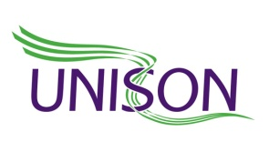

9 October 2014

Dear UNISON member

Planned Local Government Strike on 14 October now suspended

UNISON members in schools and councils took strike action on 10 July to seek an improvement on the local government employers’ 1% pay offer.

The strength of our strike action and our lobbying of councillors and MPs has resulted in the employers now putting forward new pay proposals to settle the dispute.

The proposals have the agreement of all political groups on the Local Government Association (LGA) and now need the approval of councils for them to become a formal offer from the employers.

UNISON, GMB and Unite have agreed to suspend the 14 October industrial action and consult members over the proposals whilst the LGA consults councils. This means you must not take strike action next Tuesday.

Your branch will be in touch with you about the proposals and UNISON consultation arrangements on them in the near future.

Best Wishes

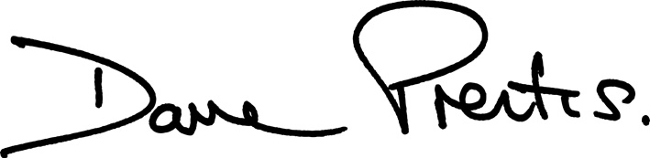

Dave Prentis
General Secretary

