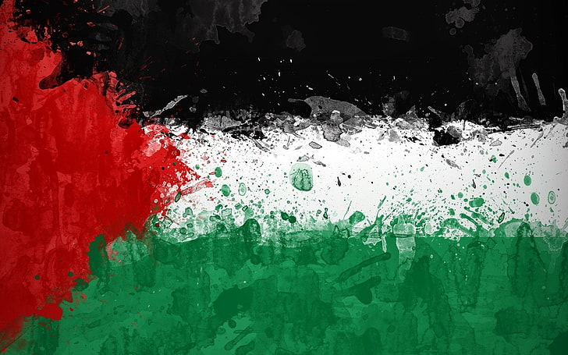
UNISON Fundraising Events
UNISON is organising the following fundraising events across West Sussex in September:

- Wednesday 10th September Peglar Lounge, County Hall, Chichester 12-2pm
- Wednesday 17th September, Ground Floor canteen, County Hall, Horsham 12-2pm
- Tuesday 23rd September 3rd floor kitchen, Bridge House, Worthing 12-2pm
We will be selling a range of items from Palestine including:
- Ceramic goods
- Art Prints
- Keffiyehs
- Food stuffs and olive oil
- Olive Wood decorations
Plus, a cake sale with all proceeds going to Medical Aid for Palestinians.


